Masthead
Publisher
Manufacturer:Jiangsu Yuyue Medical Equipment & Supply Co., Ltd
Address:No.1 Baisheng Road Development Zone, Danyang, Jiangsu
PEOPLE'S REPUBLIC OF CHINA

Tel.:86-511-86900833
Fax:86-511-86900851
Postal code:212300
Web:

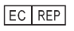
Metrax GmbH
Address:Rheinwaldstr.22, 78628 Rottweil, GERMANY
info@primedic.com
+49 (0) 741 2570

Proprietary note
The manufacturer reserves all rights to these operating instructions.Without approval from the manufacturer, these operating instructions may not be duplicated or made accessible to third parties.The same applies to individual parts or excerpts of these operating instructions.
Non-compliance with this gives rise to a right to claim damages and can have consequences under criminal law (refer to ISO 16016).

Document:24675
Revision:A
Date of issue:03/2025

These instructions for use may be changed by the manufacturer without further notice.

Contents

1Introduction HeartSave Y | YA trainer5
1.1Foreword5
1.2Validity5
1.3Intended use5
1.4Disclaimers5
2Device description6
2.1Description of device details6
2.2Language switch button11
2.3Child button11
3Preparation before starting device11
3.1Unpack11
3.2Rechargeable battery11
3.2.1Battery insertion11
3.2.2Battery removal12
4Using HeartSave Y | YA trainer12
4.1Switch on the trainer12
4.2Connect electrode cables with pads12
4.3Apply auxiliary pads13
4.3.1Placement of AED auxiliary pads13
4.3.2Method for applying the auxiliary pads13
4.3.3Feature of auxiliary pads13
4.4Apply electrodes13
4.5Inserting electrodes14
4.6Analysing rhythm15
4.6.1Start the analysis15
4.6.2Interrupt the analysis15
4.7Simulate defibrillation15
4.7.1Shock advised – Simulation: Shock recommended15
4.7.2No shock advised – Simulation: No shock recommendation15
4.8CPR – Cardiopulmonary Resuscitation15
4.8.1CPR feedback sensor16
4.9Switch off the Trainer16
5Product repair and maintenance17
5.1Device Maintenance17
5.2Electrode pads maintenance17
5.3Battery maintenance17
5.4Programming the trainer17
6Disposal18
7Technical specification18
8Warranty19
Appendix A: Index Diagram20

Introduction HeartSave Y | YA trainer

Foreword
Dear User,
You are preparing to face the task of learning to perform a competent training demonstration of the safe use of HeartSave Y | YA Trainer.The HeartSave Y | YA Trainer you have acquired is not a defibrillator but is to be used solely for educational purposes and must not be used on patients.
Realistic training scenarios will be used to simulate the use of HeartSave Y | YA in a real emergency.
A HeartSave Y | YA Trainer is clearly identified by "Trainer" printed on both sides on the side surfaces and on the nameplate.
Keep these operating instructions near the device so that you consult any queries which may arise.
For questions regarding the device or other PRIMEDIC products, we are happy to help.

Validity
The descriptions in these operating instructions refer to the HeartSave Y | YA Trainer.

Intended use
The HeartSave Y | YA Trainer may only be used as described and under the conditions detailed in these operating instructions.
Any use above or beyond this is not considered as intended use and can lead to personal injury or damage to property.

Disclaimers
Liability claims in the event of damages to people or property are excluded if they are based on one or more of the following reasons:
• Using the device in a manner for which it was not intended.
• Improper use and maintenance of the device.
• Operating the device with the protective covers removed or when there is obvious damage to cables and/or electrodes.
• Non-compliance with the instructions in these operating instructions regarding operation, maintenance and repair of the equipment.
• Using accessories and spare parts made by other manufacturers.
• Autonomous intervention, repairs or constructional changes to the device.
• Autonomous overrunning of the performance limits.
• Lack of monitoring parts that are subject to wear and tear.

Device description

Description of device details
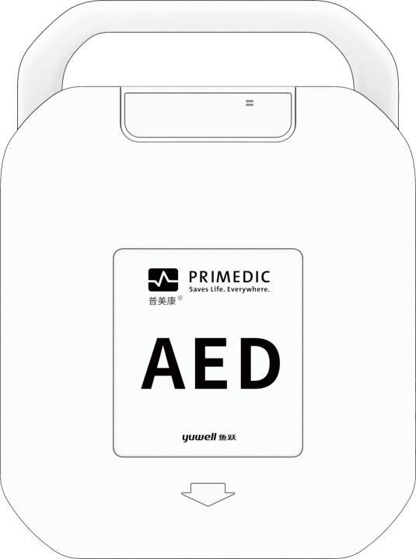
1
2
3
Fig. 1 Front view with lid
(1) Status display
(2) Device lid
(3) Open the lid as directed by the arrow
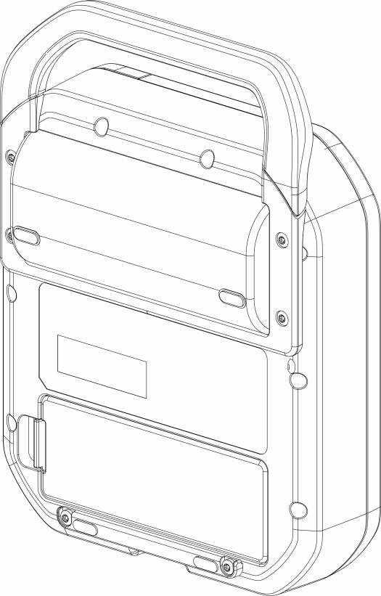
1
2
Fig. 2 Back View
(1) Carrying handle
(2) Battery
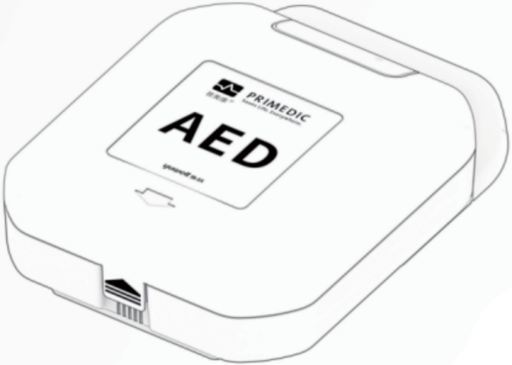
1
Fig. 3 Bottom View
- Device lid latch
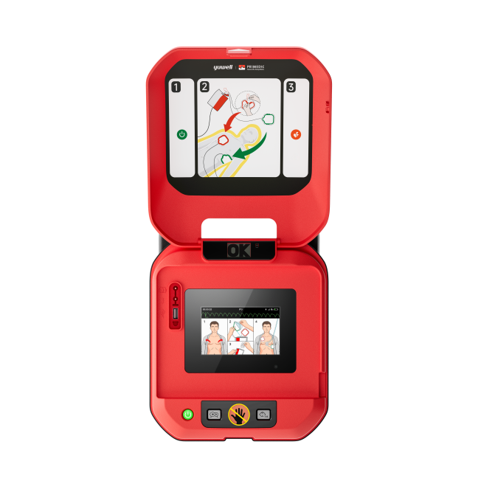
1

3
4
5
6
8
77
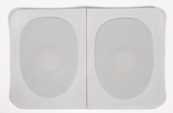
2
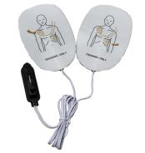
Fig. 4 HeartSave Y|YA trainer front view
(1)Socket for electrodes and USB port
(2) Training electrodes
(3) Power button
Green light on: power-on status
(4)Language button
(5)Child button
Button light on: child mode
Button light off: adult mode
- Shock button
Button light flashing:Preparing to deliver a shock.
(7) Auxiliary pads
(8) Speaker

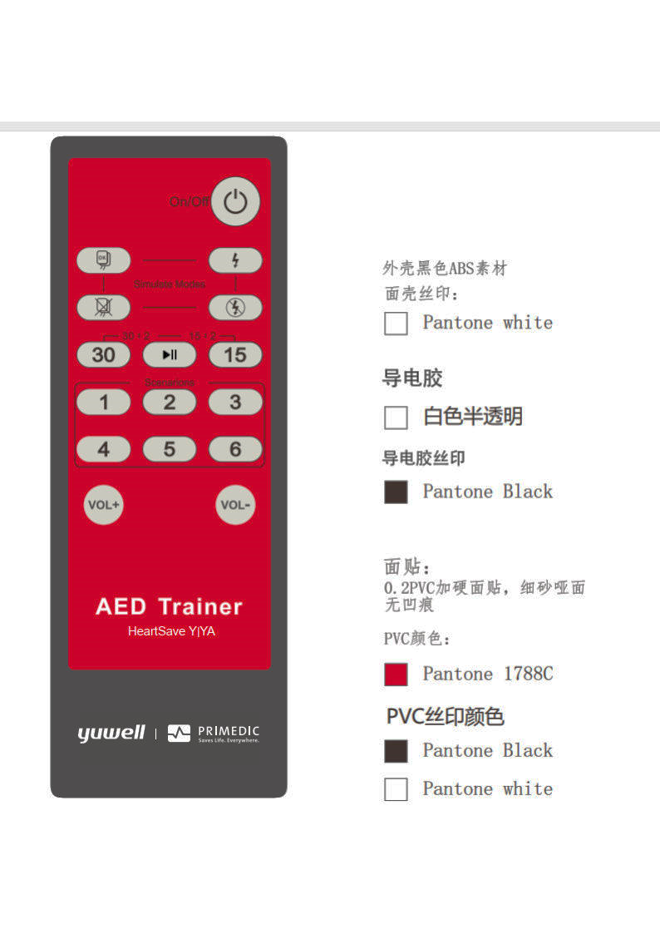
1
2
4
6
7
3
10
10
9
8
5
Fig. 5 Remote Control
- Power off Button – Switch on or off the trainer
- Standard Training Modes
There are 6 standard training models in total.Different training scenarios can be selected by pressing 1-6 keys on the remote control.The Scenarios 1 through 3 operate in fully automated mode and scenarios 4 through 6 operate in semi-automated mode.The table below shows the preset profiles that can be used.After 6 sequences the scenario start from the beginning
- 30:2 CPR Mode Switch for child mode
- 15:2 CPR Mode Switch for child mode
- Play/Pause Button
During operation, this button can be used to pause the sequence and the voice prompts.Press this button again to continue the training mode.
- Simulation:Electrodes are connected to the manikin
When the standard-training-electrodes are connected, press the button no. 6 to advice the machine that the electrodes are attached and start the rhythm analysis.
- Simulation:Electrodes are disconnected from the trainings model – only activated when electrodes are connected
- Simulation:Shock recommendation – only activated when electrodes are connected
- Simulation:No shock recommendation – only activated when electrodes are connected
- Volume +/- Key

Scenario numberDescription | DescriptionSequence | Sequence1
1  fully-automated mode | Result of each analysis:  - Shock recommended  - No shock recommended  - No shock recommended  - No shock recommended  - No shock recommended  - No shock recommended | - Defibrillation  - Two minutes CPR  - No defibrillation  - Two minutes CPR  - Rest no defibrillation
2  fully-automated mode | Result of each analysis:  - Shock recommended  - Shock recommended  - No shock recommended  - No shock recommended  - No shock recommended  - No shock recommended | - Defibrillation  - Two minutes CPR  - Defibrillation  - Two minutes CPR  - Rest no defibrillation
3  fully-automated mode | Result of each analysis:  - No shock recommended  - Shock recommended  - No shock recommended  - Shock recommended  - No shock recommended  - Shock recommended | - No defibrillation  - Two minutes compression-only CPR  - Defibrillation  - Two minutes compression-only CPR  - Rest repeat sequence above
4  semi-automated mode | Result of each analysis:  - Shock recommended  - No shock recommended  - No shock recommended  - No shock recommended  - No shock recommended  - No shock recommended | - Defibrillation  - Two minutes CPR  - No Defibrillation  - Two minutes CPR  - Rest no defibrillation
5  semi-automated mode | Result of each analysis:  - Shock recommended  - Shock recommended  - No shock recommended  - No shock recommended  - No shock recommended  - No shock recommended | - Defibrillation  - Two minutes CPR  - Defibrillation  - Two minutes CPR  - Rest no defibrillation
6  semi-automated mode | Result of each analysis:  - No shock recommended  - Shock recommended  - No shock recommended  - Shock recommended  - No shock recommended  - Shock recommended | - No defibrillation  - Two minutes compression-only CPR  - Defibrillation  - Two minutes compression-only CPR  - Rest repeat sequence above

Language switch button
You can press the language selection key during operation until the desired language is selected.The HeartSave Y | YA trainer optionally supports up to 4 languages.After each new press, the selected language is briefly announced.

Child button
Pressing the child button on the HeartSave Y | YA trainer switches the device to child mode.The default CPR instructions are changed to 15 chest compressions.Optionally, these CPR instructions can be changed to 30 cardiac compressions using the remote control.

Preparation before starting device

Unpack
When you receive the package, first check the outer packaging and the device for damage.If any damage is visible, please contact the manufacturer or distributor immediately.Provide the serial number of the back of the device and a description of the damage.

Rechargeable battery
The device uses a rechargeable lithium-ion battery.Before using the device for the first time, please be sure to insert the battery into battery slot of the device.

Battery insertion
Fig. 6 Insert the battery
Steps:
- Put the device top down on a flat surface.
- Push the (new) battery (1) in the direction of the arrow into the device until it reaches its end position as shown in the diagram.
- Then press the battery in the direction of the arrow (2) into the battery slot until the battery flap securely in the slot.
- Press the battery completely into the device until you hear a "click" when it slide into slot.
- When battery inserted, the device will carry out a self-test.Follow the voice messages.
- After self-test has been done successfully, the device is ready for use.

Battery removal
Fig. 7 Remove the battery
Steps:
- Put the device top down on a flat surface.
- Press the unlocking flap (1) to the right until the flap on the battery is released and the battery out of the slot slightly.
- Push the battery slightly in the direction of the arrow (2) and then pull it in the direction of the arrow (3) out of the device.

Using HeartSave Y | YA trainer

Switch on the trainer
The trainer can be switched on via:
- Opening the lid
- Pressing the power button of device
- Pressing the power button on the remote controller

Connect electrode cables with pads
The trainer adapts with training electrodes which includes cable and pads.
Connect the cable with training electrode pads according to Fig. 8.
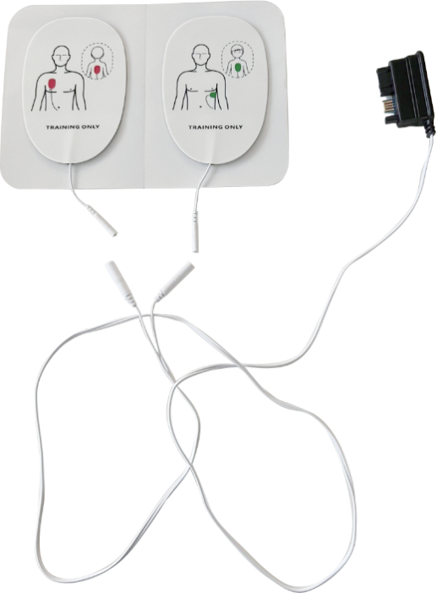
1
2
Fig. 8 Connect cables with pads
- Pads connectorCable connector
- Cable connectorApply auxiliary pads

Apply auxiliary pads
Fig. 9 Application of auxiliary pads to a manikin

Placement of AED auxiliary pads
To place the auxiliary pads on manikin, the position should be according to Fig. 9

Method for applying the auxiliary pads
Procedure:
- Open the Auxiliary pads pouch.
- Remove the protection foil from Auxiliary pads and place the auxiliary pads onto specified position.
- Press electrodes carefully to ensure good contact with manikin.

Feature of auxiliary pads
- Contact Detection: auto-detect whether trainer pads are attached during the training.
- Position Guidance:Provides visual instructions for trainer pads placement.

Apply electrodes

Fig. 10 Application of electrodes to an adult manikin
HeartSave Y|YA trainer will give a voice prompt to guide you applying electrodes to the manikin.
< Apply electrodes as shown >< Remove all clothing from patient's chest, unpack electrodes and apply them to patient's bare chest as shown >
< Remove all clothing from patient's chest, unpack electrodes and apply them to patient's bare chest as shown >Steps:
Steps:
- Open the pouch to take out the training electrodes.
- For models without auxiliary electrodes, place the training electrodes on the corresponding positions of the manikin as shown in the illustration on the training electrodes.For models with auxiliary electrodes, first attach the auxiliary electrodes to the positions indicated for training electrodes in the illustration, and then place the training electrodes on the auxiliary electrodes.

NOTE | - The training electrode pads are shared for both children and adults, as shown in the figure above.  - The training electrode pads have similar looking to real defibrillators in appearance but do not give high-voltage shocks.Please note training electrode pads are for training purposes ONLY and must not be connected to a defibrillator for emergency use.  - Do not bend or stretch the electrode cables or pads.  - For auxiliary electrode pads, first attach the auxiliary electrode pads to the manikin, and then place the training electrode pads over the auxiliary electrode pads.

Inserting electrodes
Insert the connector into the socket
Fig. 11 Inserting electrodes
Steps:
- Pull the latch to allow the lid to be opened.
- Insert the electrodes plug into the socket.
- Place the electrodes into the device.

Analysing rhythm

Start the analysis
In case of electrodes connected, there are two options to start the analysis:
- Connect electrode connector to the trainer.The analysis starts when training electrodes attached with auxiliary electrodes.
- Press button 6 (Fig. 5) on the remote control to start the analysis.
When analysis starts you will hear the voice prompts:
< Analysing rhythm >< Don’t touch the patient >
< Don’t touch the patient >Interrupt the analysis

Interrupt the analysis
In case of analysis starts, there are several options to interrupt the analysis:
- Interrupt the analysis by disconnect one pad
- Press button 7 (Fig. 5) on the remote control
- Remove the electrodes connector from device socket.

Simulate defibrillation
The result of the analysis refers to the selected scenario on the remote control.

Shock advised – Simulation:Shock recommended
When press button 8 (Fig.5 Remote Control), the current scenario is interrupted and simulate a shock recommendation immediately not depending on the before chosen scenario.There will be an analysis right after pressing the button and the trainer will always recommend a shock for the next sequences.
NOTE | Only available when trainer electrodes are connected.

No shock advised – Simulation:No shock recommendation
When press button 9 (Fig.5 Remote Control), the current scenario is interrupted and simulate a no shock recommendation immediately not depending on the before chosen scenario.There will be an analysis right after the pressing the button and the trainer will always recommend no shock for the next sequences.
NOTE | Only available when trainer electrodes are connected.

CPR – Cardiopulmonary Resuscitation
The duration of the CPR is approx. 120s consists of chest compressions and rescue breaths.Adult and child should follow different compression recommendations as below.

Adult mode30:2 Adult CPR Mode, following the standard CPR procedure.
30:2 Adult CPR Mode, following the standard CPR procedure.
Device prompts:
< Begin CPR >< Give 30 chest compressions >
< Give 30 chest compressions >< Give two rescue breaths >
< Give two rescue breaths > OR (under mode 3 or 6)
OR (under mode 3 or 6)
< Begin CPR >< Perform chest compressions for 2 minutes >
< Perform chest compressions for 2 minutes >Child mode

Child mode15:2 Paediatric CPR Mode, also possible to switch to 30 compressions.
15:2 Paediatric CPR Mode, also possible to switch to 30 compressions.
Device prompts:
< Begin CPR >< Give 15 chest compressions >
< Give 15 chest compressions >< Two rescue breaths>
< Two rescue breaths>OR (under mode 3 or 6)
OR (under mode 3 or 6)
< Begin CPR >< Perform chest compressions for 2 minutes >
< Perform chest compressions for 2 minutes >NOTE
NOTE | For auxiliary electrode pads:If the electrode plug is disconnected during CPR, the CPR process will be interrupted, and the device will prompt < Stop chest compression>. If CPR is initiated due to unattached electrode pads and the pads are subsequently attached, the CPR process will also be interrupted, and the device will prompt < Stop chest compression>.

CPR feedback sensor
When CPR feedback sensor applied, during CPR, the compression frequency and depth will be prompted acoustically or visually.There will be prompts for no compressions, bad compressions, or good compressions.The compression quality is calculated based on the average measurement from 1-15 compressions of each cycle.
A compression frequency between 100 and 120 compressions per minute is considered normal.
If the average compression frequency is too slow, the device will prompt < Press faster >.
If the average compression frequency is too fast, the device will prompt < Press slower >.
A compression depth between 50mm and 60mm is considered normal.
If the average compression depth is too shallow, the device will prompt < Press harder >.
If the average compression depth is too deep, the device will prompt < Press lighter >.
If CPR sensor is not used, the device will prompt < Use CPR sensor to improve CPR quality >.
If all compressions with good quality, the device will prompt < Compression quality good, keep it up >.
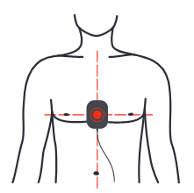
Fig. 12 Position for CPR Feedback Sensor

Switch off the Trainer
The trainer can be switched off via:
- Pressing the power button of the device
- Closing the lid of device
- Pressing “On/Off” button on the remote control

Product repair and maintenance

Device Maintenance
- Please clean the main unit with a soft cloth with water or neutral detergent.
- Do not use gasoline to clean the trainer.
- Please do not let liquids such as water flow into the device.
- Do not store the trainer in places exposed to direct sunlight, high temperature, humidity, dust and corrosive gases.Please refer to chapter 7.

Electrode pads maintenance
- The electrode pads should be kept clean to avoid dust, oil and dirt.
- Please do not scratch the adhesive surface.
- Please do not clean the electrodes with water or other liquids.
- Do not store the electrodes in places exposed to direct sunlight, high temperature, humidity, dust and corrosive gases.

Battery maintenance
- Do not charge/discharge over the specified current.
- Do not short circuit the battery pins, it may cause permanent damage.
- Do not burn or destroy the battery.
- Store batteries in a cool and dry place.
- Keep away from children.
NOTE | Rechargeable battery maintenance instruction  Periodic charging and discharging - If the battery is planned to store for a long period (> 6 months), it is recommended to fully discharge the battery and recharge it once every half year.
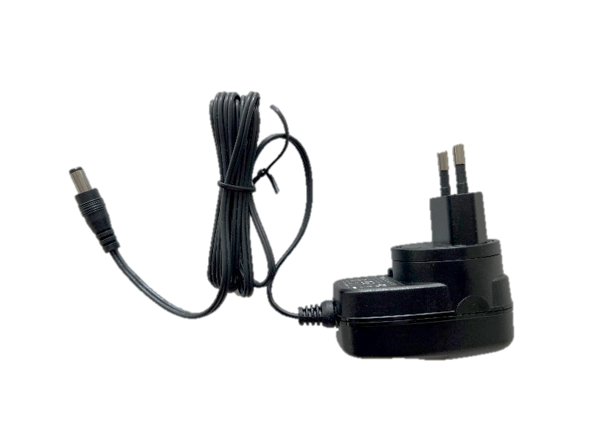
2
1
图 13 电源适配器
(1) 电源插座插头
(2)充电线插头

编程训练器
训练器提供更新软件或配置的可能性。要更新软件或配置，您需要准备：
- 1 个 USB 驱动器
- 1 台电脑
USB 驱动器必须符合以下规格：
- 容量不超过 32GB
- 格式：FAT32
- USB 2.0/USB 2.0 读卡器
USB 驱动器更新程序：
将 USB 驱动器插入 USB 端口，然后打开 AED 训练器电源。屏幕亮起后，按住语音按钮，直到出现程序更新界面，然后等待更新完成。
NOTE | 在更新过程中，语音按钮将闪烁。  完成指示灯：语音按钮保持稳定亮起，或设备重新启动（更新配置文件后，您可以再次导出以检查是否成功修改）。  故障指示灯：语音按钮熄灭。

处置
在设备使用寿命结束时，请将其交给当地回收公司。正确处置本设备有助于环境保护。

技术规格
设备
电源 | 7.4V（可充电锂电池）
关机时残余电流 | ≤ 2mA
操作时额定电流 | ≤ 500mA
尺寸（长 x 宽 x 高） | 29.6厘米 x 22.0厘米 x 9.7厘米 (±0.1厘米)
重量 | 1.59公斤 (±0.3公斤)
电池电源适配器 | 输入交流 100-240V  输出直流 12V 1A
遥控器
电源 | DC 3.0V (AAA battery x 2)
关机时残余电流 | 5 µA
操作时额定电流 | 10 mA
ENVIRONMENT SPECIFICATIONOperating conditions
Operating conditions
Temperature | 5°C – 40°C
Relative humidity | ≤ 80% without condensation
Air pressure | 86kPa – 106kPa
Storage conditions
Temperature | -20°C – 55°C
Relative humidity | ≤ 93% without condensation
Air pressure | 70kPa – 106kPa

Warranty
Jiangsu Yuyue Medical Equipment & Supply Co., Ltd. undertakes a 2-year warranty period for this equipment from the date of purchase.Please keep the purchase certificate properly.
During this period, the company will exclude defects and malfunctions of this equipment due to materials or production free of charge.At the company's option, repair or replacement will be used for maintenance.
The fulfilment of the warranty responsibility does not extend the original warranty period.Warranty and legal guarantee requirements do not apply to these situations: the usability has not been greatly affected, natural wear and tear (such as electrode pads consumables), or caused by wrang or wrang operation, excessive use and special external force influences other than those specified in the manual damage, and the purchaser or a third party has not modified or repaired the equipment in accordance with the regulations.
Other contractual or non-contractual demands on the company are excluded, unless these demands are based on deliberate acts, negligent acts or mandatory legal liability principles.
lf you need warranty, please send the equipment, purchase certificate (such as a copy of the invoice) and warranty card to your seller or our company.
After the warranty period, the company will continue to provide you with after-sales service but will charge a certain fee accordingly.

Appendix A: Index Diagram
Fig. 1 Front view with lid6
Fig. 2 Back View7
Fig. 3 Bottom View8
Fig. 4 HeartSave Y|YA trainer front view8
Fig. 5 Remote Control9
Fig. 6 Insert the batterySteps:11
Fig. 7 Remove the battery12
Fig. 8 Connect cables with pads13
Fig. 9 Application of auxiliary pads to a manikin13
Fig. 10 Application of electrodes to an adult manikin14
Fig. 11 Inserting electrodes15
Fig. 12 Position for CPR Feedback Sensor16
Fig. 13 Power-Adapter17

